A
Project Report
on

PROJECT_Name

XXXX

College Certificate

ACKNOWLEDGEMENT

The present of this report gives us the feeling. As the final frontier toward achieving a BCA, the activity of going through industrials orientation has bridged the gap between the academics and practical real-life work for me. It has prepared us to apply ourselves to become good IT professional. Naturally, it requires lot of people support to complete this project. We take this opportunity to acknowledge their support to us.

We sincerely thank our department for the academic advancement, it has provided to us during last years and finally provide us an opportunity for project work. We thank Prof. Sunil Bhajeja , Head of the computer department. for his support through the project.

Last but not the least, we would like to thank our parents and our friends who had helped us indirectly throughout the project duration and have been the source of encouragement.

And finally, our sincere thanks to our batch-mats, who had provided us with innumerable discussions on many technicalities and friendly tips. Without their cordial and friendly support, this activity has been much tougher.

PROJECT_NAME

Index

TABLE OF CONTENTS
Title: Page No:
CANDIDADATE'S DECLARATION…………………………………………1
COLLEGE CERTIFICATE……………………………………………………2
ACKNOWLEDGEMENT……………………………………………………...3
ABSTRACT…………………………………………………………………….4

CHAPTER-1 Introduction………………………………………………5
CHAPTER-2 System Analysis…………………………………………...8
2.1 Definition...................................................................................8
2.2 Description of present system………………………………..8
2.3 Limitations of present system………………………………..8
2.4 Proposed System……………………………………………...9
2.5 Feasibility Study………………………………………………9
2.5.1 Technical Feasibility………………………………..10
2.5.2 Economical Feasibility……………………………..10
2.5.3 Behavioral/ Operational Feasibility……………….11
2.6 Project Planning and Scheduling …………………………….12
2.7 Software Engineering Paradigm Applied………………………14

CHAPTER-3 System Specifications……………………………………..15
3.1 Hardware Description…………………………………………15
3.2 Software Description..................................................................15

CHAPTER-4 Organization Profile………………………………………16
CHAPTER-5 Overview of the language used…………………………...17
5.1 About HTML…………………………………………………17
5.2 About Java Script…………………………………………….24
5.3 About PHP……………………………………………………25
5.4 About MySql………………………………………………….26
5.5 About Database………………………………………………29

CHAPTER-6 System Design…………………………………………....37
6.1 Output Design………………………………………………..37
6.2 Input Design………………………………………………….38
6.3 Logical Design………………………………………………..38
6.4 Data Flow Diagram…………………………………………..39
6.5 Data Dictionary………………………………………………40
6.6 ER – Diagram………………………………………………..42
6.7 Process Model………………………………………………..42

CHAPTER-7 Coding………………………………………………….44
7.1 Source Code………………………………………………..45

CHAPTER-8 Testing…………………………………………………46
8.1 Black box Testing…………………………………………46
8.2 White box Testing…………………………………………46
8.3 Software Testing Strategies………………………………47

CHAPTER-9 Security………………………………………………...48
CHAPTER-10 Screenshots ………………………49
CHAPTER-11 Future Enhancement…………………………………50
CHAPTER-12 Conclusion and Discussion……………………………50
CHAPTER-13 Bibliography……………………………………………50

1. INTRODUCTION

Online Trading is useful for buy Cumin, Fennel, Isabgul(White), Sarsav(Yellow), Raido(Mustard), Castor seed, Till Seasame, Groundut, Asalio (Red), Raigaro, Feuqqreek (Yellow), Moog (Green), Math (Shuffish), Udid (Black), Gram, Tur etc. thought APMC, Unjha.

ADD Your Project Introduction from Synopsis

- SYSTEM ANALYSIS

2.1 DEFINATION

System Analysis is the detailed study of the various operations performed by the system and their relationships within and outside the system. Analysis is the process of breaking something into its parts so that the whole may be understood. System analysis is concerned with becoming aware of the problem, identifying the relevant and most decisional variables, analyzing and synthesizing the various factors and determining an optimal or at least a satisfactory solution. During this a problem is identified, alternate system solutions are studied and recommendations are made about committing the resources used to design the system

2.2 DESCRIPTION OF PRESENT SYSTEM

Existing system refers to the system that is being follow till now. Presently all the registrations are done manually. If a person wants to buy jeera, variyari, taj etc., he should directly contact the APMC,Unjha office. The main disadvantage is that there will be lot of difficulties for the citizens. So, all these procedures will be a time consuming one.
2.3 LIMITATIONS OF PRESENT SYSTEM

- Difficult for persons.
- Time consuming.
To avoid all these limitations and make the working more accurately the system needs to be computerized.

2.4 PROPOSED SYSTEM
Online Trading is aimed at developing a web-based system. In this system the person can sales online and do many things. The details of all the things are made available to them through the website.

ADVANTAGES
- This website provides online help for legal queries.
- This website helps all the users to view the registration.
- The user can post thread in the forum.
- The system is user friendly.

2.5 FEASIBILITY STUDY
A feasibility analysis usually involves a through assessment of the operational (need), financial and technical aspects of a proposal. Feasibility study is the test of the system proposal made to identify whether the user needs may be satisfied using the current software and hardware technologies, whether the system will be cost effective from a business point of view and whether it can be developed with the given budgetary constraints. A feasibility study should be relatively cheap and done at the earliest possible time. Depending on the study, the decision is made whether to go ahead with a more detailed analysis.

When a new project is proposed, it normally goes through feasibility assessment. Feasibility study is carried out to determine whether the proposed system is possible to develop with available resources and what should be the cost consideration. Facts considered in the feasibility analysis were.

- Technical Feasibility
- Economic Feasibility
- Behavioral Feasibility

2.5.1 Technical Feasibility

Technical Feasibility deals with the hardware as well as software requirements. Technology is not a constraint to type system development. We have to find out whether the necessary technology, the proposed equipments have the capacity to hold the data, which is used in the project, should be checked to carryout this technical feasibility.
The technical feasibility issues usually raised during the feasibility stage of investigation includes these
- This software is running in windows 2000 Operating System, which can be easily installed.
- The hardware required is Pentium based server.
- The system can be expanded.

2.5.2 Economical Feasibility
This feasibility study present tangible and intangible benefits from the prefect by comparing the development and operational cost. The technique of cost benefit analysis is often used as a basis for assessing economic feasibility. This system needs some more initial investment than the existing system, but it can be justifiable that it will improve quality of service.

Thus feasibility study should center along the following points:

- Improvement resulting over the existing method in terms of accuracy, timeliness.
- Cost comparison
- Estimate on the life expectancy of the hardware
- Overall objective
Our project is economically feasible. It does not require much cost to be involved in the overall process. The overall objectives are in easing out the requirement processes.

2.5.3 Behavioral/ Operational Feasibility

This analysis involves how it will work when it is installed and the assessment of political and managerial environment in which it is implemented. People are inherently resistant to change and computers have been known to facilitate change. The new proposed system is very much useful to the useful to the users and there for it will accept broad audience from around the world.

2.6 PROJRCT PLANNING & SCHEDULING

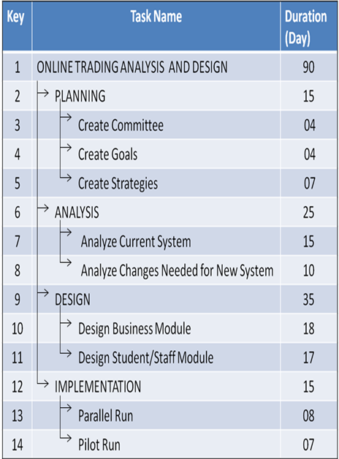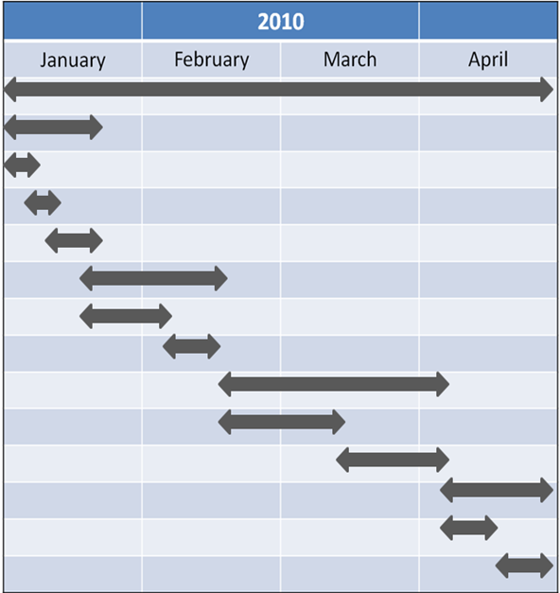

  - SOFTWARE ENGINEERING PARADIGM APPLIED
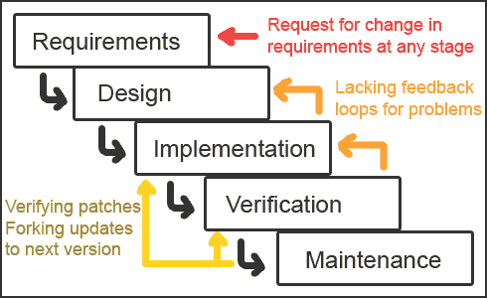

Waterfall Model

The waterfall model derivers its name due to the cascading effect from one phase to the other as is illustrated in above figure. In this model each phase well define starting and ending point, with identifiable deliveries to the next phase. Note that this model is sometime referred to as the linear sequential model or the software life cycle model. The water fall diagram is basically divided into following 5 models.

          - Requirement
          - Design
          - Implementation
          - Verification
          - Maintenance

  - Requirement:-

In the requirement phase the need to create the application is specified. What is the need of the system is defined. What information to be feeder to create the application will come under the requirement phase?

  - Design:

After the requirement phase the next phase is the Design phase where the application is designed according to the forms and other modules created. This phase is much important phase because it will structure the layout of your application.

  - Implementation:

Implementation is the process of having a system personnel phase check out and put new equipment into use, train users, install new application and construct any file of data need to use it.

  - Verification:

After the whole application is being the developed the main phase is the verification phase where the whole application tested and verified to check the whole application.

  - Maintenance:
After the successful verification of the application the main phase is the maintenance phase where the application needs to be maintained for its successful operation in future.

3. SYSTEM SPECIFICATIONS

3.1 HARDWARE DESCRIPTION

The selection of hardware is very important in the existence and proper working of any software. When selecting hardware, the size and requirements are also important.

Minimum Requirements:
Processor : Pentium II class, 450MHz
RAM : 128MB
Hard Disk Drive : 3GB
Video : 800X600, 256 colors
CD-ROM : Required

The proposed System is developed on:
Processor : INTEL Pentium 4
RAM : 512MB
Hard Disk Drive : 40GB
Key Board : Standard 101/102 or Digi Sync Family
Monitor : Display Panel (1024 X 764)
Display Adapter : Trident Super VGA
Network Adapter : SMC Ethernet Card Elite 16 Ultra
Mouse : Logitech Serial Mouse

3.2 SOFTWARE DESCRIPTION

Operating System : Windows XP and higher
Front- End : HTML,CSS,JAVA SCRIPT
Back- End : PHP,MYSQL
.

4. ORGANIZATIONAL PROFILE
Not Necessary
Did under college Guide,you can mention few lines about Guide

5. OVERVIEW OF THE LANGUAGE USED

5.1 About Html:-

UNDERSTANDING HTML

- HTML was originated by Tim Berners-Lee.
- HTML developed a few years ago as a subset of SGML (Standard Generalized Mark-up Language), which is a higher-level mark-up language that has long been a favorite of the Department of Defense.
- Any HTML document is also valid for SGML.
- HTML is a Hyper Text Markup Language that is used to develop web pages.
- HTML is not a programming language like C, C++ and Java etc.
- It is a cross platform markup language that is design to be flexible enough to display text and other elements like graphical on a variety of views.
- The HTML documents consists of special Tags that are embedded in an ASCII document.
- Web browser like Internet Explorer, Netscape Navigator etc, interprets these Tags.

Basic HTML
Tag | Description
<!DOCTYPE> | Defines the document type
<html> | Defines an HTML document
<head>
Defines information about the document
<title>
Defines a title for the document
<body> | Defines the document's body
<h1> to <h6> | Defines HTML headings
<p> | Defines a paragraph
<br> | Inserts a single line break
<hr> | Defines a thematic change in the content
<!--...--> | Defines a comment

Formatting
Tag | Description
<abbr> | Defines an abbreviation or an acronym
<address> | Defines contact information for the author/owner of a document/article
<b> | Defines bold text
<bdi> | Isolates a part of text that might be formatted in a different direction from other text outside it
<bdo> | Overrides the current text direction
<blockquote> | Defines a section that is quoted from another source
<cite> | Defines the title of a work
<code> | Defines a piece of computer code
<del> | Defines text that has been deleted from a document
<dfn> | Represents the defining instance of a term
<em> | Defines emphasized text
<i> | Defines a part of text in an alternate voice or mood
<ins> | Defines a text that has been inserted into a document
<kbd> | Defines keyboard input
<mark> | Defines marked/highlighted text
<meter> | Defines a scalar measurement within a known range (a gauge)
<pre> | Defines preformatted text
<progress> | Represents the progress of a task
<q> | Defines a short quotation
<rp> | Defines what to show in browsers that do not support ruby annotations
<rt> | Defines an explanation/pronunciation of characters (for East Asian typography)
<ruby> | Defines a ruby annotation (for East Asian typography)
<s> | Defines text that is no longer correct
<samp> | Defines sample output from a computer program
<small> | Defines smaller text
<strong> | Defines important text
<sub> | Defines subscripted text
<sup> | Defines superscripted text
<template> | Defines a template
<time> | Defines a date/time
<u> | Defines text that should be stylistically different from normal text
<var> | Defines a variable
<wbr> | Defines a possible line-break
Forms and Input
Tag | Description
<form> | Defines an HTML form for user input
<input> | Defines an input control
<textarea> | Defines a multiline input control (text area)
<button> | Defines a clickable button
<select> | Defines a drop-down list
<optgroup> | Defines a group of related options in a drop-down list
<option> | Defines an option in a drop-down list
<label> | Defines a label for an <input> element
<fieldset> | Groups related elements in a form
<legend> | Defines a caption for a <fieldset> element
<datalist> | Specifies a list of pre-defined options for input controls
<output> | Defines the result of a calculation

Frames
Tag | Description
<iframe> | Defines an inline frame

Images
Tag | Description
<img> | Defines an image
<map> | Defines a client-side image-map
<area> | Defines an area inside an image-map
<canvas> | Used to draw graphics, on the fly, via scripting (usually JavaScript)
<figcaption> | Defines a caption for a <figure> element
<figure> | Specifies self-contained content
<picture> | Defines a container for multiple image resources
<svg> | Defines a container for SVG graphics

Audio / Video
Tag | Description
<audio> | Defines sound content
<source> | Defines multiple media resources for media elements (<video>, <audio> and <picture>)
<track> | Defines text tracks for media elements (<video> and <audio>)
<video> | Defines a video or movie

Links
Tag | Description
<a> | Defines a hyperlink
<link> | Defines the relationship between a document and an external resource (most used to link to style sheets)
<nav> | Defines navigation links

Lists
Tag | Description
<ul> | Defines an unordered list
<ol> | Defines an ordered list
<li> | Defines a list item
<dl> | Defines a description list
<dt> | Defines a term/name in a description list
<dd> | Defines a description of a term/name in a description list
<menu> | Defines a list/menu of commands
<menuitem> | Defines a command/menu item that the user can invoke from a popup menu

Tables
Tag | Description
<table> | Defines a table
<caption> | Defines a table caption
<th> | Defines a header cell in a table
<tr> | Defines a row in a table
<td> | Defines a cell in a table
<thead> | Groups the header content in a table
<tbody> | Groups the body content in a table
<tfoot> | Groups the footer content in a table
<col> | Specifies column properties for each column within a <colgroup> element
<colgroup> | Specifies a group of one or more columns in a table for formatting

Styles and Semantics
Tag | Description
<style> | Defines style information for a document
<div> | Defines a section in a document
<span> | Defines a section in a document
<header> | Defines a header for a document or section
<footer> | Defines a footer for a document or section
<main> | Specifies the main content of a document
<section> | Defines a section in a document
<article> | Defines an article
<aside> | Defines content aside from the page content
<details> | Defines additional details that the user can view or hide
<dialog> | Defines a dialog box or window
<summary> | Defines a visible heading for a <details> element
<data> | Links the given content with a machine-readable translation

Meta Info
Tag | Description
<head> | Defines information about the document
<meta> | Defines metadata about an HTML document
<base> | Specifies the base URL/target for all relative URLs in a document

Programming
Tag | Description
<script> | Defines a client-side script
<noscript> | Defines an alternate content for users that do not support client-side scripts
<embed> | Defines a container for an external (non-HTML) application
<object> | Defines an embedded object
<param> | Defines a parameter for an object

5.2 About JavaScript:-

- What is JavaScript?

- JavaScript was designed to add interactivity to HTML pages
- JavaScript is a scripting language (a scripting language is a lightweight programming language)
- A JavaScript consists of lines of executable computer code
- A JavaScript is usually embedded directly into HTML pages
- JavaScript is an interpreted language (means that scripts execute without preliminary compilation)
- Everyone can use JavaScript without purchasing a license

- Are Java and JavaScript the Same?

- NO! Java and JavaScript are two completely different languages in both concept and design!
- Java (developed by Sun Microsystems) is a powerful and much more complex programming language - in the same category as C and C++.

- What can a JavaScript Do?

- JavaScript gives HTML designers a programming tool - HTML authors are normally not programmers, but JavaScript is a scripting language with a very simple syntax! Almost anyone can put small "snippets" of code into their HTML pages

JavaScript Syntax.

- Unlike HTML, JavaScript is case sensitive.
- Dot Syntax is used to combine terms.
e.g., document.write("Hello World")
- Certain characters and terms are reserved.
JavaScript is simple text (ASCII).

JavaScript Terminology

- JavaScript programming uses specialized terminology.
- Understanding JavaScript terms is fundamental to understanding the script.
- Objects, Properties, Methods, Events, Functions, Values, Variables, Expressions, Operators.

5.3 About Php:-

- Introduction to PHP:

- The full form of PHP is “Hypertext Preprocessor”. Its original name was “Personal Home Page”
- Rasmus Lerdorf software engineer, Apache team member is the creator and original driving force behind PHP. The first part of PHP was developed for his personal use in late 1994.
- By the middle of 1997, PHP was being used on approximately 50,000 sites worldwide.
- PHP is server-side scripting language, which can be embedded in HTML or used as a stand-alone.
- PHP doesn’t do anything about what a page looks and sounds like. In fact, most of what PHP does is invisible to the end user.
- Someone looking at a PHP page will not necessarily be able to tell that it was not written purely in HTML, because usually the result of PHP is HTML.
- PHP is an official module of Apache HTTP Server.
- PHP is fully cross-platform, meaning it runs native on several flavors of Unix, as well as on Windows and now on Mac OS X.

- Advantages of PHP

- Cost: PHP costs you nothing. It is open source software and doesn’t need to purchase it for development.
- Ease of Use: PHP is easy to learn, compared to the others. A lot of Ready-made PHP scripts are freely available in market so, you can use them in your project or get some help from them.
- HTML- Support: PHP is embedded within HTML; In other words, PHP pages are ordinary HTML pages that escape into PHP mode only when necessary. When a client requests this page, the web server preprocesses it. This means it goes through the page from top to bottom, looking for sections of PHP, which it will try to resolve.
- Cross-platform compatibility: MySQL run native on every popular flavor of Unix and windows. A huge percentage PHP and of the world’s HTTP servers run on one of these two classes of operating system.
- PHP is compatible with the three leading Web servers: Apache HTTP Server for Unix and Windows, Microsoft Internet Information Server, and Netscape Enterprise Server.

It also works with several lesser-known servers, including Alex Blits’ fhttpd, Microsoft’s Personal Web Server, AOL Server and Omnicentrix’s Omni server application server.

- Stability: The word stable means two different things in this context:
    - The server doesn’t need to be rebooted often
    - The software doesn’t change radically and incompatibly from release to release.

To our advantage, both of these apply to both MySQL and PHP.

- Speed: PHP is pleasingly zippy in its execution, especially when compiled as and Apache module on the Unix side. Although it takes a slight performance hit by being interpreted rather than compiled, this is far outweighed by the benefits PHP drives from its status as a Web server module.

5.4 About MySql:-

- MySQL Database Management System

- MySQL, the most popular Open Source SQL database management system, is developed, distributed, and supported by MySQL AB.
- MySQL AB is a commercial company, founded by the MySQL developers. It is a second generation Open Source Company that unites Open Source values and methodology with a successful business model.
- The MySQL Web site (http://www.mysql.com/) provides the latest information about MySQL software and MySQL AB.
- The official way to pronounce “MySQL” is “My Ess Que Ell” (not “my sequel”), but we don't mind if you pronounce it as “my sequel” or in some other localized way.

- MySQL Features:
  - MySQL is a database management system.
  - MySQL is a relational database management system.
  - MySQL software is Open Source.
  - The MySQL Database Server is very fast, reliable, and easy to use.
  - MySQL Server works in client/server or embedded systems.
  - A large amount of contributed MySQL software is available.

- SYSTEM DESIGN
DEFINATION

The most creative and challenging face of the system development is System Design. It provides the understanding and procedural details necessary for implementing the system recommended in the feasibility study. Design goes through the logical and physical stages of development.

In designing a new system, the system analyst must have a clear understanding of the objectives, which the design is aiming to fulfill. The first step is to determine how the output is to be produced and in what format. Second, input data and master files have to be designed to meet the requirements of the proposed output. The operational phases are handled through program construction and testing.

Design of a system can be defined as a process of applying various techniques and principles for the purpose of defining a device, a process or a system in sufficient detail to permit its physical realization. Thus system design is a solution to “how to” approach to the creation of a new system. Thus important phase provides the understanding and the procedural details necessary for implementing the system recommended in the feasibility study. The design step provides a data design, architectural design, and a procedural design.

6.1 OUTPUT DESIGN

In the output design, the emphasis is on producing a hard copy of the information requested or displaying the output on the CRT screen in a predetermined format. Two of the most output media today are printers and the screen. Most users now access their reports from a hard copy or screen display. Computer’s output is the most important and direct source of information to the user, efficient, logical, output design should improve the systems relations with the user and help in decision-making.

As the outputs are the most important source of information to the user, better design should improve the system’s relation and also should help in decision-making. The output device’s capability, print capability, print capability, response time requirements etc should also be considered form design elaborates the way output is presented and layout available for capturing information. It’s very helpful to produce the clear, accurate and speedy information for end users.

6.2 INPUT DESIGN

In the input design, user-oriented inputs are converted into a computer based system format. It also includes determining the record media, method of input, speed of capture and entry on to the screen. Online data entry accepts commands and data through a keyboard. The major approach to input design is the menu and the prompt design. In each alternative, the user’s options are predefined. The data flow diagram indicates logical data flow, data stores, source and destination. Input data are collected and organized into a group of similar data. Once identified input media are selected for processing.

In this software, importance is given to develop Graphical User Interface (GUI), which is an important factor in developing efficient and user-friendly software. For inputting user data, attractive forms are designed. User can also select desired options from the menu, which provides all possible facilities.

Also the important input format is designed in such a way that accidental errors are avoided. The user has to input only just the minimum data required, which also helps in avoiding the errors that the users may make. Accurate designing of the input format is very important in developing efficient software. The goal or input design is to make entry as easy, logical and free from errors.

6.3 LOGICAL DESIGN

Logical data design is about the logically implied data. Each and every data in the form can be designed in such a manner to understand the meaning. Logical data designing should give a clear understanding and idea about the related data used to construct a form.

6.4 DATA FLOW DIAGRAM

A Data Flow Diagram (DFD) is a diagram that describes the flow of data and the processes that change data throughout a system. It’s a structured analysis and design tool that can be used for flowcharting in place of or in association with information. Oriented and process oriented system flowcharts. When analysts prepare the Data Flow Diagram, they specify the user needs at a level of detail that virtually determines the information flow into and out of the system and the required data resources. This network is constructed by using a set of symbols that do not imply physical implementations. The Data Flow Diagram reviews the current physical system, prepares input and output specification, specifies the implementation plan etc.

Four basic symbols are used to construct data flow diagrams. They are symbols that represent data source, data flows, and data transformations and data storage. The points at which data are transformed are represented by enclosed figures, usually circles, which are called nodes.

6.5 DATA FLOW DIAGRAM SYMBOLS:-

- Source or Destination of data

- Data Flow

- Process

- Storage

Steps to Construct Data Flow Diagrams:-

Four steps are commonly used to construct a DFD
- Process should be named and numbered for easy reference. Each name should be representative of the process.
- The destination of flow is from top to bottom and from left to right.
- When a process is exploded in to lower level details they are numbered.
- The names of data stores, sources and destinations are written in capital letters.

Rules for constructing a Data Flow Diagram
- Arrows should not cross each other.
- Squares, circles and files must bear names.
- Decomposed data flow squares and circles can have same names.
- Draw all data flow around the outside of the diagram.

Paste your DFD diagrams

6.6 ER – Diagram

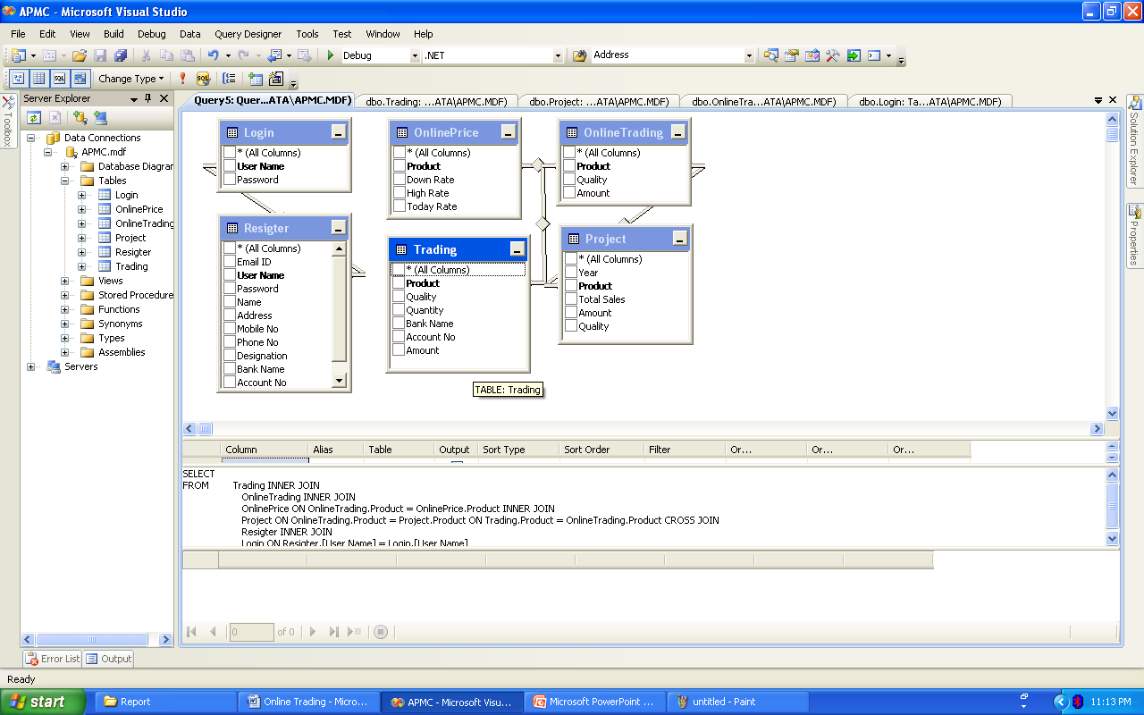
Write your data dictionary

6.7 Process Model

Spiral Model
DEFINITION - The spiral model, also known as the spiral lifecycle model, is a systems development method (SDM) used in information technology (IT). This model of development combines the features of the prototyping model and the waterfall model. The spiral model is intended for large, expensive, and complicated projects.

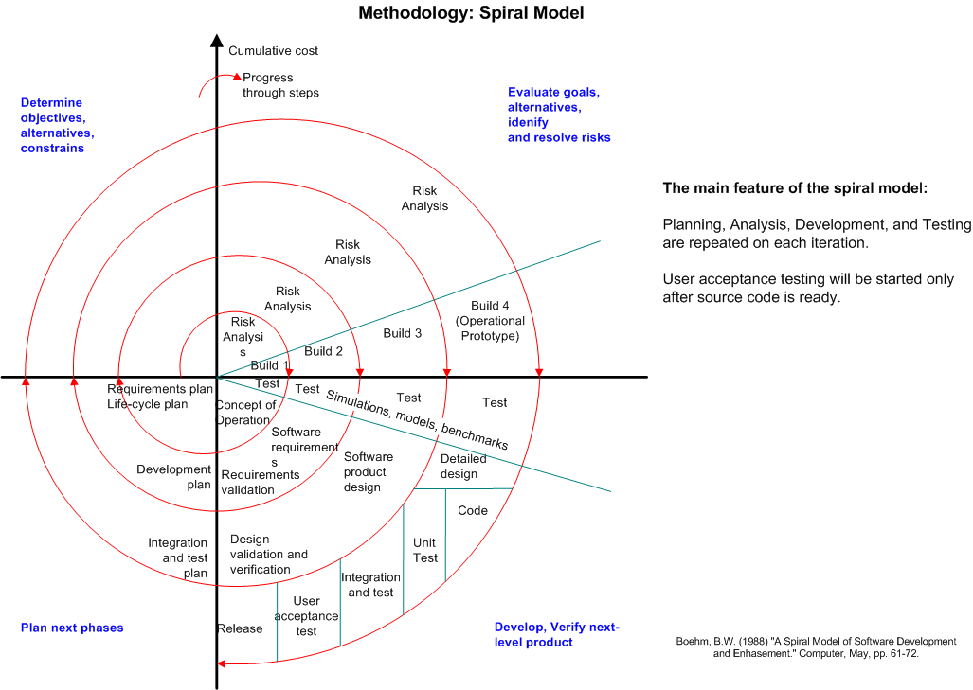

The steps in the spiral model can be generalized as follows:
- A preliminary design is created for the new system.

- A first prototype of the new system is constructed from the preliminary design. This is usually a scaled-down system, and represents an approximation of the characteristics of the final product.

- A second prototype is evolved by a fourfold procedure:
(I) evaluating the first prototype in terms of its strengths, weaknesses,
And risks;
(ii) Defining the requirements of the second prototype;
(iii) Planning and designing the second prototype;
(iv) Constructing and testing the second prototype.

- At the customer's option, the entire project can be aborted if the risk is deemed too great. Risk factors might involve development cost overruns, operating-cost miscalculation, or any other factor that could, in the customer's judgment, result in a less-than-satisfactory final product.

- The existing prototype is evaluated in the same manner as was the previous prototype, and, if necessary, another prototype is developed from it according to the fourfold procedure outlined above.

- The preceding steps are iterated until the customer is satisfied that the refined prototype represents the final product desired.

- The final system is constructed, based on the refined prototype.

- The final system is thoroughly evaluated and tested. Routine maintenance is carried out on a continuing basis to prevent large-scale failures and to minimize downtime.

Advantages
- Estimates (i.e. budget, schedule, etc.) get more realistic as work progresses, because important issues are discovered earlier.
- It is more able to cope with the (nearly inevitable) changes that software development generally entails.
- Software engineers (who can get restless with protracted design processes) can get their hands in and start working on a project earlier.

- CODING

First phase of implementation is coding. Coding can be done in two ways. One by automatic program code and other by programmer’s manually written code. A code generator is a suite of programs that matches the input to an appropriate code template and from these produces modules of code.
The code is made simple in such a way that another programmer can easily understand and work on that in future. The crucial phase in the system development life cycle is the successful implementation of the new system design. The process of converting as new or revised system into an operational one is known as system implementation.
This includes all those activities that take place to convert from an old system to a new system. The system can be implemented only after a through testing is done and if it is found to work according to the specifications. The most crucial stage in achieving a new successful system and giving confident on the new system for the users is that it will work effectively and efficiently. If involves careful planning, investigation of the current system and its constraints on implementation, design of methods to achieve the change over.

SOURCE CODE
Paste Your CODE HERE
PAGE WIZE

- TESTING
Testing is a process to show the correctness of the program. Testing is needed to show completeness, it improve the quality of the software and to provide the maintenance aid. Some testing standards are therefore necessary reduce the testing costs and operation time. Testing software extends throughout the coding phase and it represents the ultimate review of configurations, design and coding. Based on the way the software reacts to these testing, we can decide whether the configuration that has been built is study or not. All components of an application are tested, as the failure to do so many results in a series of bugs after the software is put to use.

7.1 Blackbox Testing
Blackbox testing, also called behavioral testing, focuses on the functional requirements of software. This testing approach enables the software engineer to derive the input conditions that will fully exercise all requirements for a program. Blackbox testing attempts to find the errors like
- Incorrect or missing functions
- Interface errors
- Errors in datastructures or external database access
- Behavior or performance errors
- Initialization and termination errors
In Blackbox testing software is exercised over a full range of inputs and outputs are observed for correctness.

7.2 Whitebox Testing
Whitebox testing is also called Glassbox testing is a test case design control; structure of the procedural design to derive test cases using Whitebox testing method, the software engineer can derive the test cases that guarantee that all independent paths within the module have been exercised at least once. Exercise all logic decisions on their true or false sides. Execute all loops at their boundaries and within their operational bounds. Exercise internal datastructure to ensure their validity.
7.3 Software Testing Strategies
Testing involves
- Unit testing
- Integration testing
- Acceptance testing

The first level of test is unit testing. The purpose of unit testing is to ensure that each program is fully tested.
The second step is integration testing. In this individual program units or programs are integrated and tested as a complete system to ensure that the software requirements are met.
Acceptance Testing involves planning and the execution of various types of tests in order to demonstrate that the implemented software system satisfies the requirements. Finally our project meets the requirements after going through all the levels of testing.

- SECURITY
The system security problem can be divided into four related issues: security, integrity, privacy and confidentiality. They determine the file structure, data structure and access procedures.

System security refers to the technical innovations and procedures applied to the hardware and operating systems to protect against deliberate or accidental damage from a defined threat. In contrast, data security is the protection of data from loss, disclosure, modifications and destruction
.
System integrity refers to the proper functioning of programs, appropriate physical security and safety against external threats such as eavesdropping and wiretapping. In comparison, data integrity makes sure that do not differ from original from others and how the organization can be protected against unwelcome, unfair or excessive dissemination of information about it.

The term confidentiality is a special status given to sensitive information in a data base to minimize the possible invasion of privacy. It is an attribute of information that characterizes its need for protection. System security is the technical means of providing such protection. In contrast privacy is largely a procedural matter of how information is used.

- SCREEN SHOTS
SCREEN SHOTS

FUTURE ENHANCEMENT
Now the users can only do buy through online. All the remaining procedures are done manually. In future we can do full process through online. Online Trading team can apply for the tie up or authorization from all the Agriculture Product Market Committee. It Provide easy way for framer to sales them product.

CONCLUSION
Now a day’s manual process for the citizens to sales for their product such like jeera, variyari, taj, white isbqgul etc… has become a huge task. The main object of the website is to reduce the effort by the candidate and save his time and avoid unwanted rushes at the APMC and assure a smooth working schedule at APMC for Trading.
The main features of this site includes flexibility, reduce manual work in an efficient manner, a quick, convenient, reliable and effective way to apply for their agriculture market committee records. The project could very well be enhanced further as per the requirements.

BIBLIOGRAPHY

- Websites

www.dynamicdrive.com
www.w3schools.com

www.phpeasystep.com

- Books

PHP Bible

PHP 5.

